Accessing your Job Description in PeopleAdmin

Access the PeopleAdmin Position Descriptions Module by following this link: https://hartford.peopleadmin.com/hr.
Your login screen will appear as the below. As a reminder, all University employees have access to the PeopleAdmin portal. All users’ initial login credentials are as follows:
Username – first portion of your University email account
Password – University ID number (please ensure you update your password if you have not already)

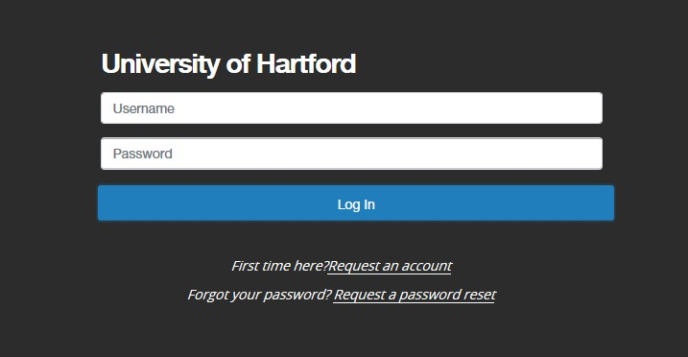
NOTE: If you cannot log in for any reason, please email questions to thibodeau@hartford.edu. Please know that you will already have an account created, and do not need to request a new one.

The Welcome Screen appears after you log in, and should appear similar to the following screen:
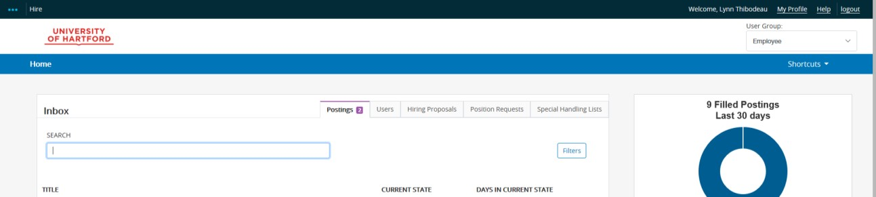

On the far right hand side of the screen, set the permission user group to "Employee" by using the provided drop down menu.
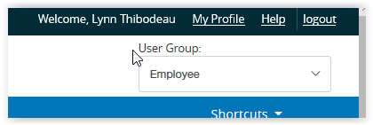

Next, click on the three blue dots on the left side of the window to see the menu for the other modules available to you.
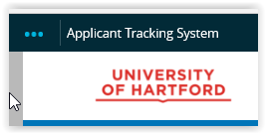

Choose Position Management from the menu.
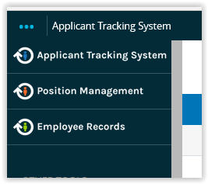

Your screen will update and the menu elements will now appear on an orange bar.

Choose Position Descriptions on the orange bar, and then Staff from the drop down menu.

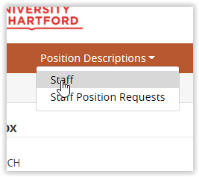

Only your Position Description will show up. Click on your title and your position description is available to you. (note – if you are supervisor, you will also have access to all employee job descriptions of employees within all departments who report to up to you.)

